Java Introduction
Java is an Object-Oriented Programming language developed by James Gosling at Sun Microsystems
Sun Microsystems is acquired by Oracle Corp in 2010
Object Oriented Concepts/Features
- Objects
- Classes
- Abstraction
- Encapsulation
- Inheritance
- Polymorphism

Object
An object is a real time entity which has identity, state and behaviour
An object is the real thing created from the class

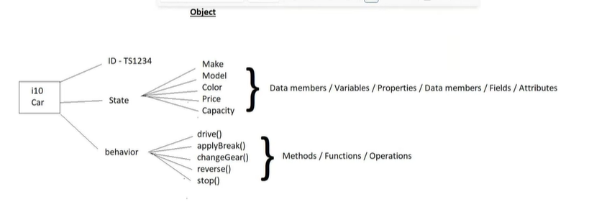
Class
A Class is a collection of data members and methods
Class is a blueprint or Design
- What properties something has
- What actions it can do
But it is just a plan not the real thing

The members (data members/Methods) of the class are accessed using objects with dot(.) operator

🏠 Real World Example 1 – House
- Class → House design (2 bedrooms, 1 kitchen, color, etc.)
- Object → Actual house built using that design
You can build:
- House1 (blue)
- House2 (white)
- House3 (big balcony
All are objects of the same class.
🚗 Real World Example 2 – Car
- Class → Car (color, speed, start (), stop ())
- Object → BMW car, Audi car, Tesla car
Each car is different, but all come from the same car design.

